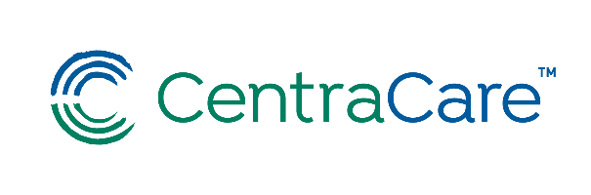April 7, 2021 or April 14, 2021 (Choose One)

**Please RSVP by Emailing**

[**VannurdenA@centracare.com**](mailto:VannurdenA@centracare.com)

Presented Via WebEx

7:30 – 10:00 a.m.

Opportunities in Clinical Documentation Integrity

10:00 – 11:00 a.m.

Evaluation and Management (E&M) Levels for Professional Services

**Low Hanging Fruit for Acute Care Practice**

**Jessie Roske, MD**

**Objectives:**

At the conclusion of this presentation, participants should be able to:

* Understand the impact of documentation for accurate reflection of patient severity of illness (SOI), risk of mortality (ROM), DRG assignment, and care outcomes Identify possible modifications to personal documentation structure(s) of encounter notes.
* Recognize opportunities for documentation of relevant acute and chronic conditions with essential diagnosis specificity and the tools provided to support optimal provider documentation.
* Understand the basic elements that determine Evaluation and Management levels for a patient encounter.
* Identify possible modifications to personal documentation structure(s) of encounter notes.

CentraCare is accredited by the Minnesota Medical Association to provide continuing medical education for physicians.

CentraCare designates this live activity for a maximum of 3.00 *AMA PRA Category 1 Credit(s)™*. Physicians should claim only the credit commensurate with the extent of their participation in the activity.

This education offering has been designed to meet the Minnesota Board of Nursing continuing education requirements for 3 contact hours. It is the personal responsibility of each participant to determine whether this activity meets the requirements for acceptable continuing education by the licensing organization.

Please contact the Medical Staff Development Office at (320) 255-5836 if you have special mobility, vision, hearing, or other needs.



CME