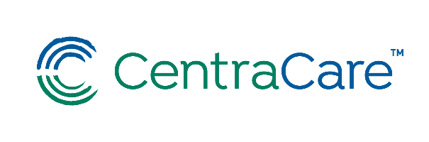September 15, 2022

Presented Via WebEx – [Click Here to Join](https://centracare.webex.com/centracare/j.php?MTID=m9ac501dd035cb8556b32cb961504323d)

12:00 – 1:00 p.m.

**Fireside Chat:**

**Evaluation and Management**

**Documentation Education**

**Copy Forward:**

**How to Use a Powerful Tool Correctly**

**Jesse Roske, MD**

**Objectives:**

If used properly, these tools can maximize your time efficiently so you can return your focus back to the bedside and carry information along in highly complex patients. However, if used incorrectly they can propagate errors in the EMR and create an enormous red flag for auditors.

At the end of this session participants will:

* Review ideas about the importance of an evolving comprehensive narrative for our complex patients.
* View demonstrations by an Epic informaticist who will join us to explore best use of Copy and Paste/Copy Forward functions in the EMR.

Please contact the Medical Staff Development Office at (320) 255-5836 if you have special mobility, vision, hearing, or other needs.

CentraCare is accredited by the Minnesota Medical Association to provide continuing medical education for physicians.

CentraCare designates this live activity for a maximum of 1.00 *AMA PRA Category 1 Credit(s)™*. Physicians should claim only the credit commensurate with the extent of their participation in the activity.



CME